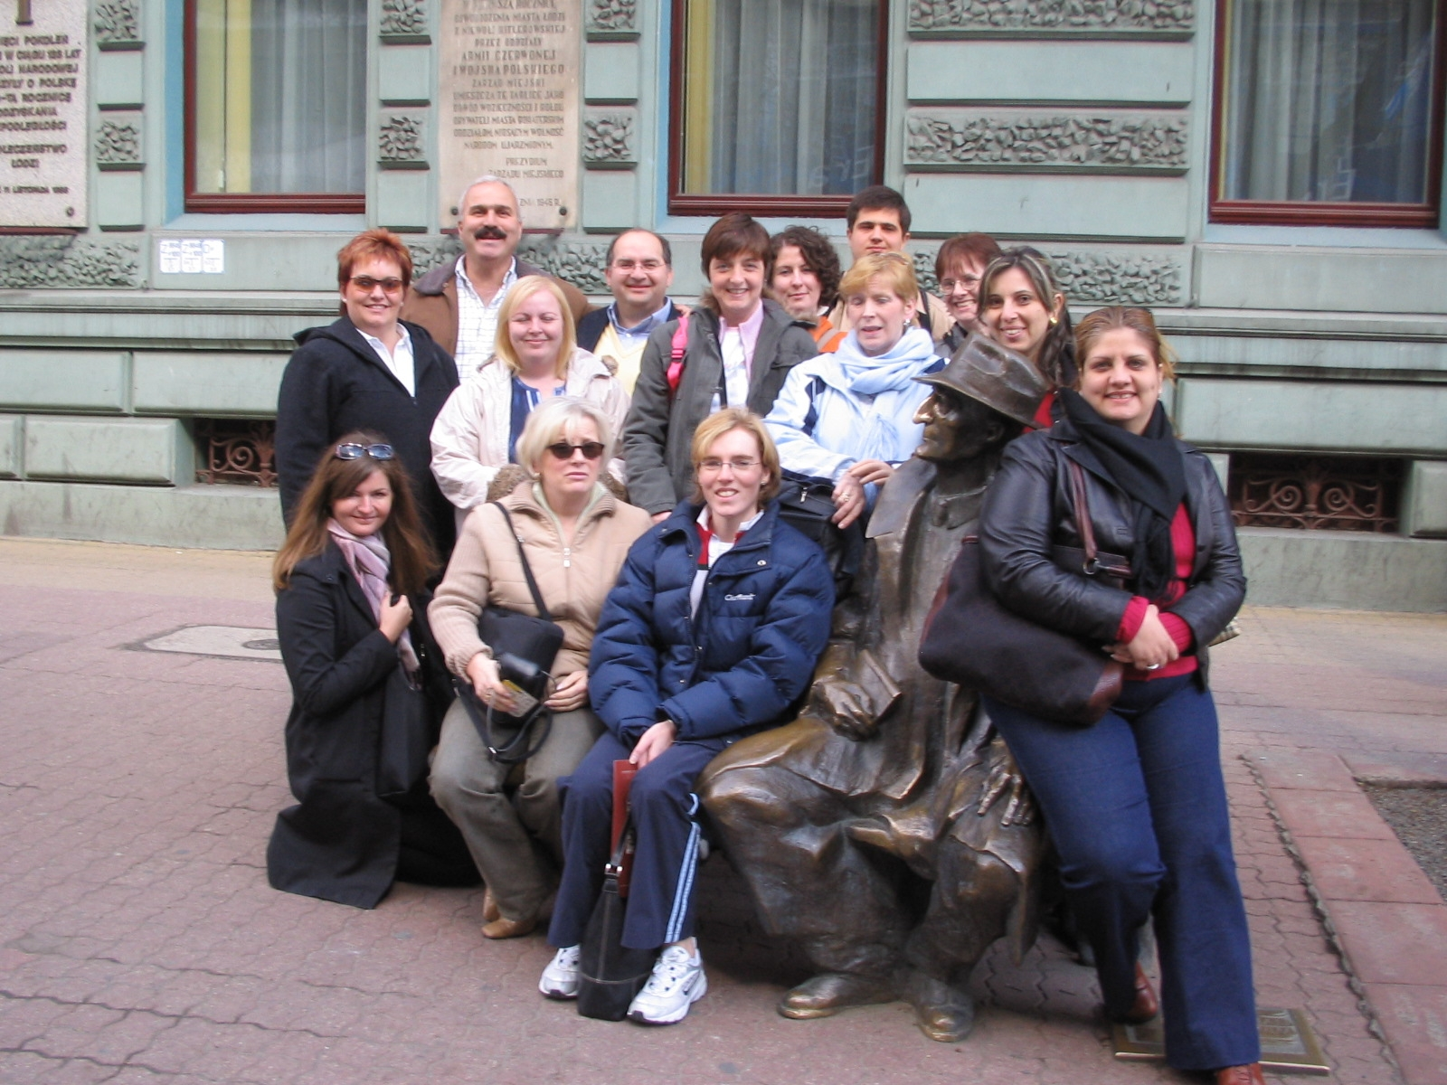SMILEY FACES – EUROPEAN LEARNING BAGS

Progress report by Polish partner

MAY 2004

Since the beginning of the project in October 2003 CPN (Polish partner) decided, due to low project’s budget to join Smiley Faces with similar project run by GAJUSZ Foundation. The Foundation got the money for training volunteers working with sick children so we’ve thought of combining it with working out learning bags as the final product of that training.
The project designed and realised in Poland is aimed at people who work with children suffering from protracted and serious illnesses such as cancer. It will be used by volunteers who regularly look after sick children. The project contains both elements of therapy and development. Its programme has been designed in such a way as to allow the volunteers to organise different games and exercises on a step-by-step basis as well as adjust them to the cognitive potential, emotional problems and social development. Due to the lack of space and other conditions limiting our work, Polish Learning Bags will constitute mostly of exercises with instructions and only few materials needed. During the whole project our team should be able to work out 5 learning bags, each covering different subject and skills.
As for now we’ve identified 15 volunteers who work for the project, taking part in workshops, lectures and meetings. The whole training and project is run by three psychologist and in cooperation with Haematology and Oncological Ward in Children’s Clinic.
During the meetings “Good Ideas Bank” has been created and the work on instructions’ development and compilation of games and recreation started. The adjustment to the situation of the sick children, their cognitive and emotional problems as well as interpersonal relations, has been taken into consideration.
We had also lectures on medical information on neoplasms in children and their treatment, psychological reflection of illness, individual contact with sick children in the situation of providing care.
In April 2004 Poland hosted the second transitional meeting of Smiley Faces, which we found fruitful and successful.

